TOPIC: JOINS AND SET OPERATIONS
PART 1: CROSS JOIN
STEP 1: CREATE TABLES
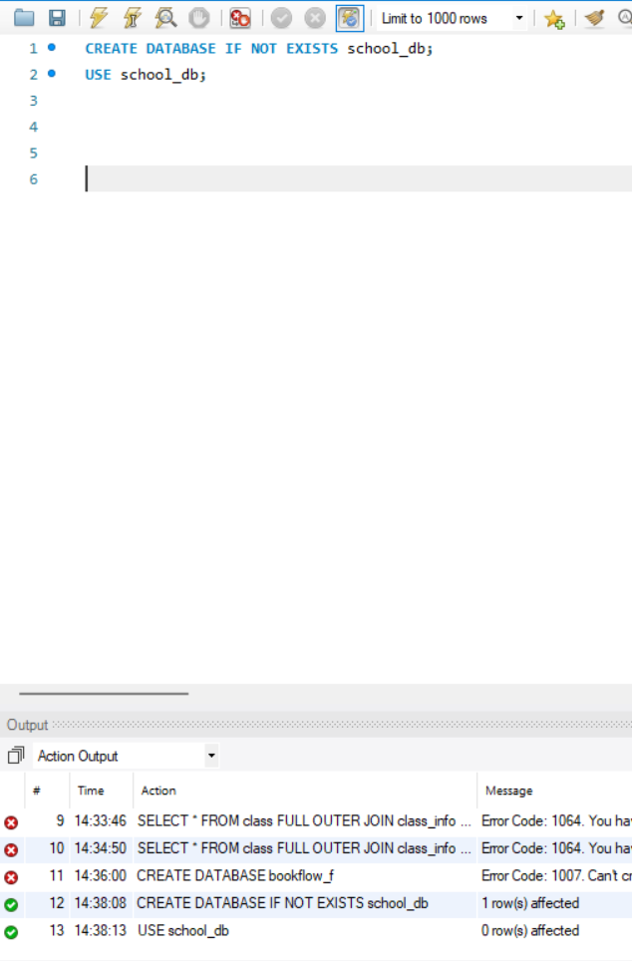
Step 2: Create Tables for Joins
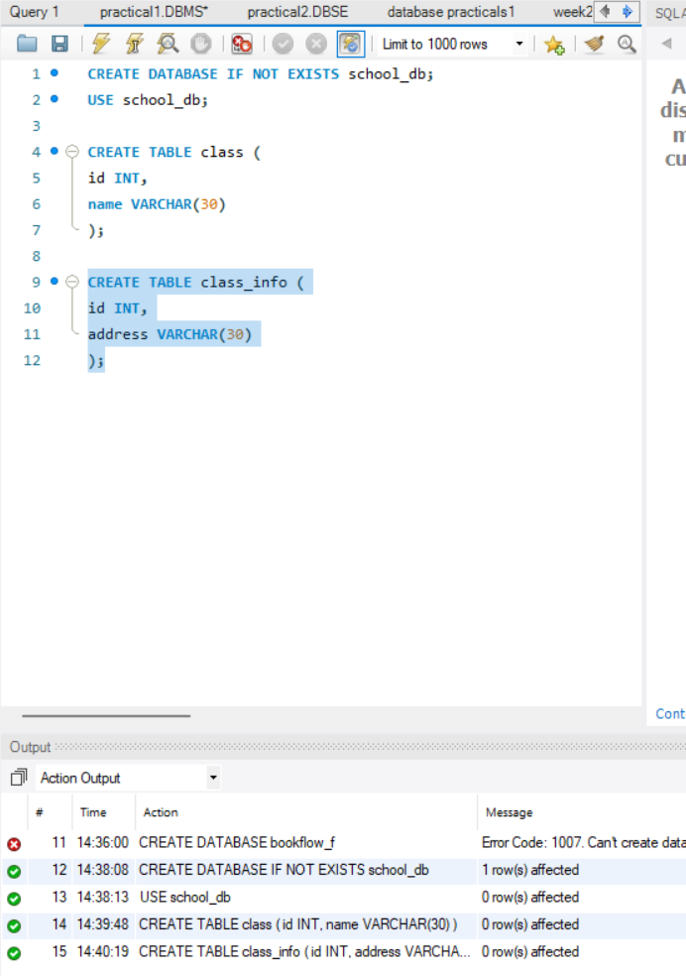
Step 3: Insert Data for Cross Join
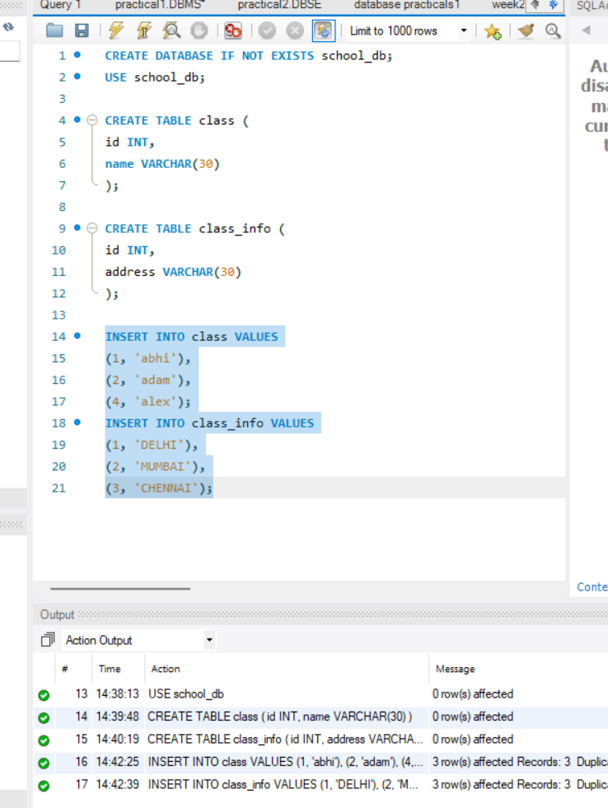
Step 4: Cross Join Query
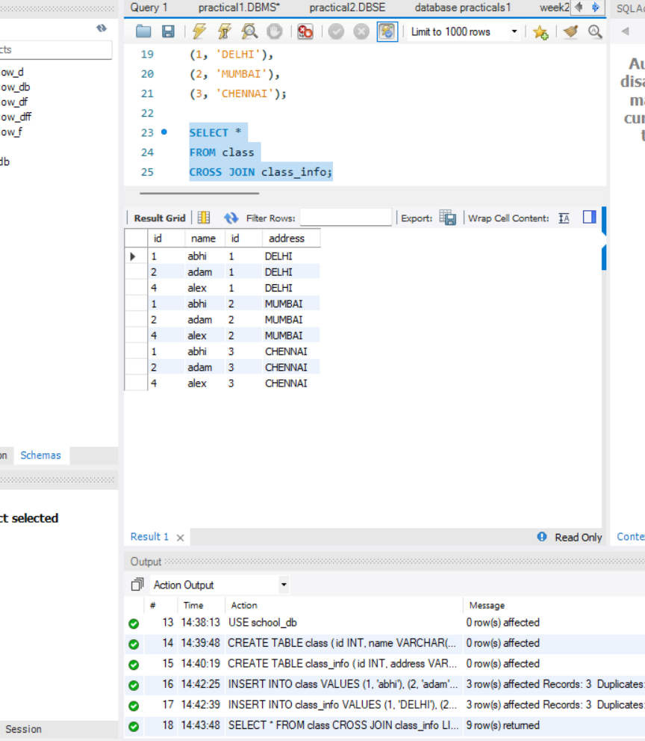
Step 5: Reset Data for Main Joins
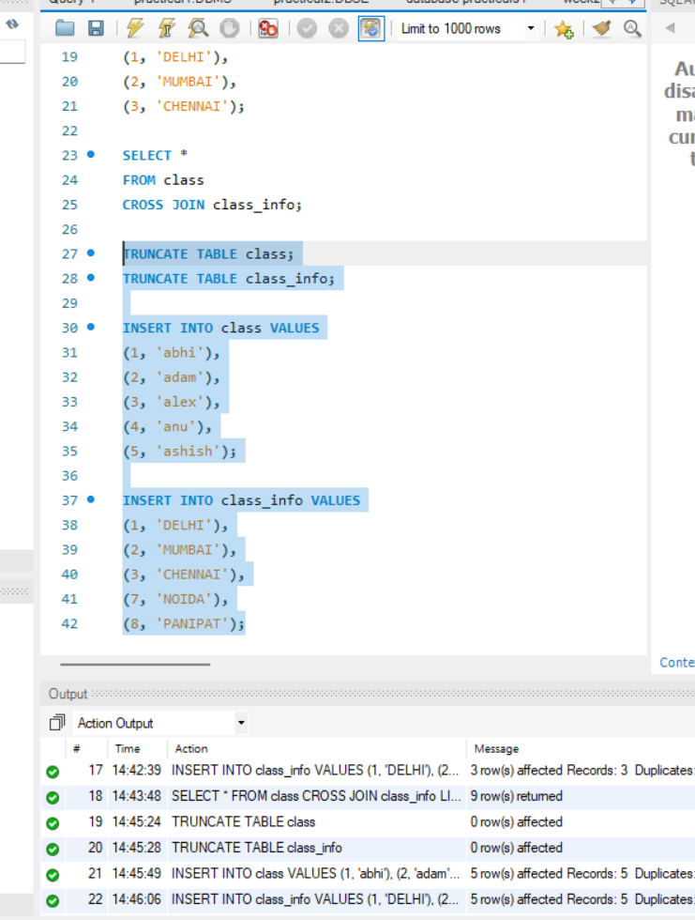
Step 6: Inner Join Queries
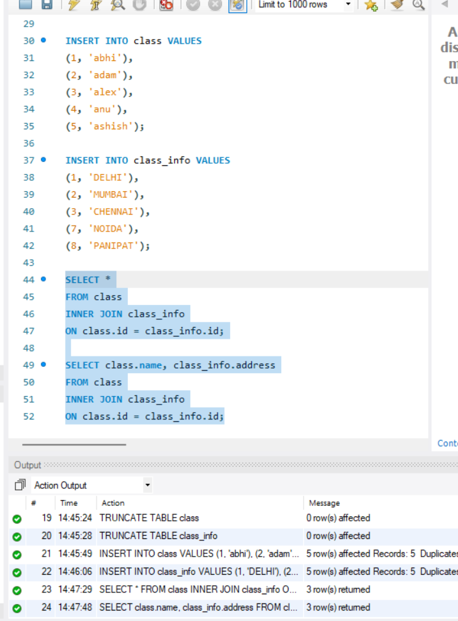
Step 7: Natural Join Query
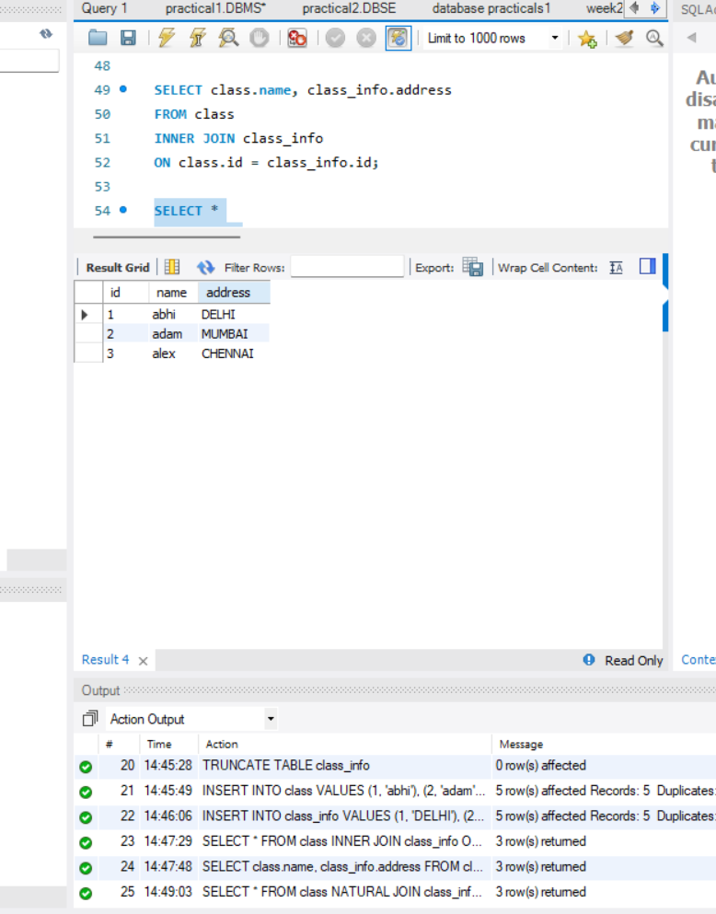
Step 8: Left Outer Join Queries
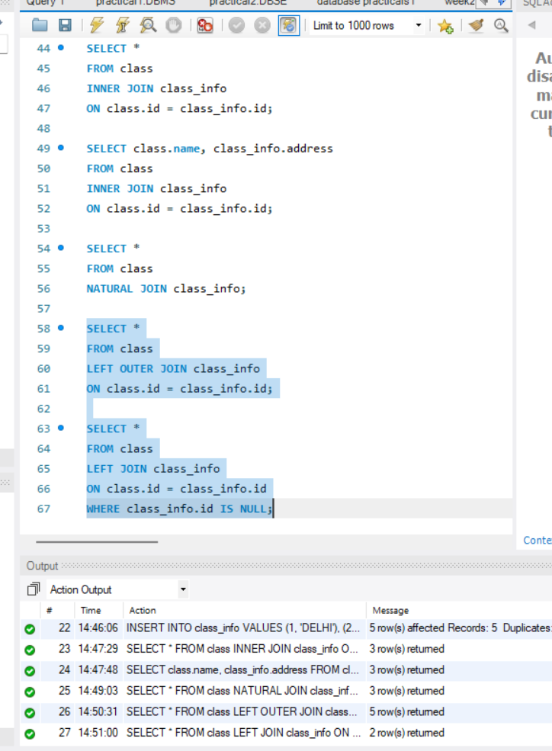
Step 9: Right Outer Join Queries
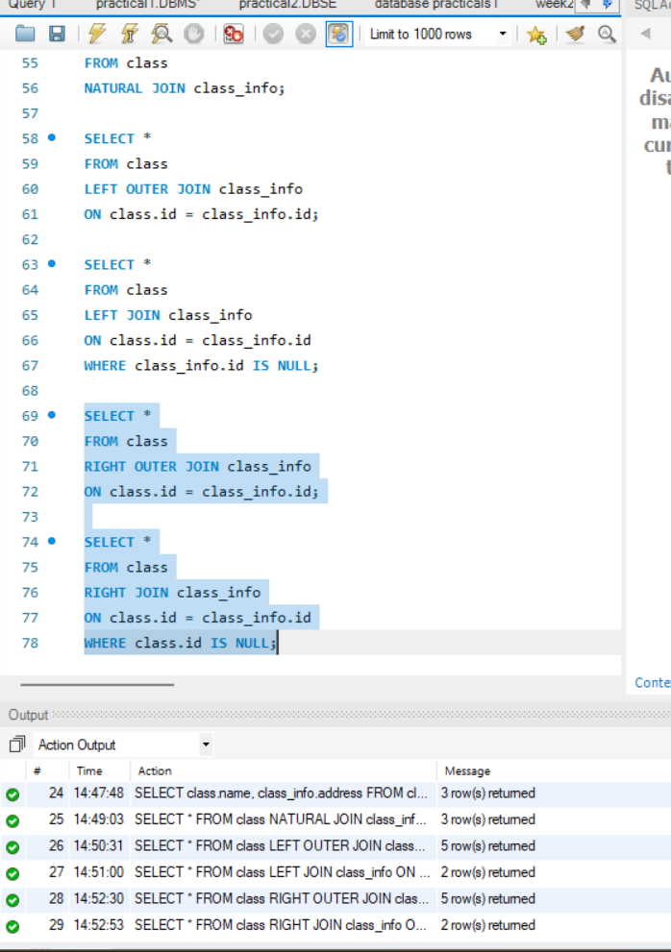
Step 10: Full Outer Join Queries
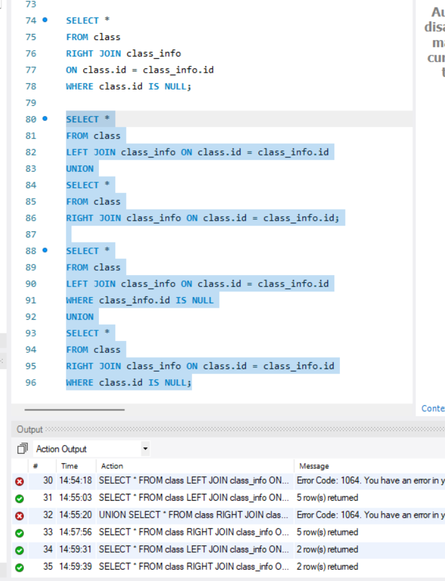
Step 11: Setup Tables for Set Operations
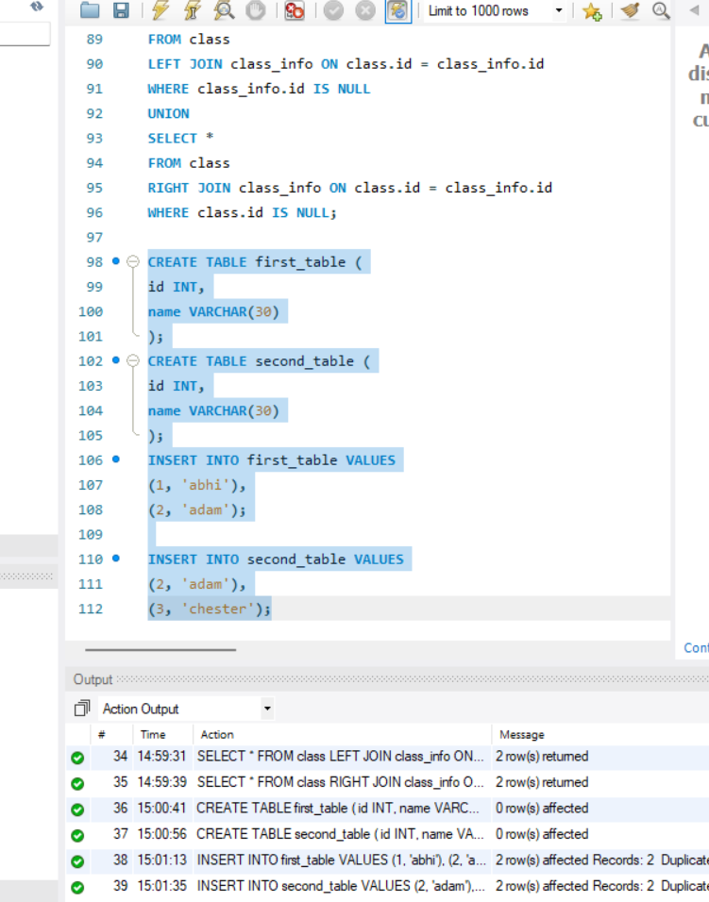
Step 12: Union Operations
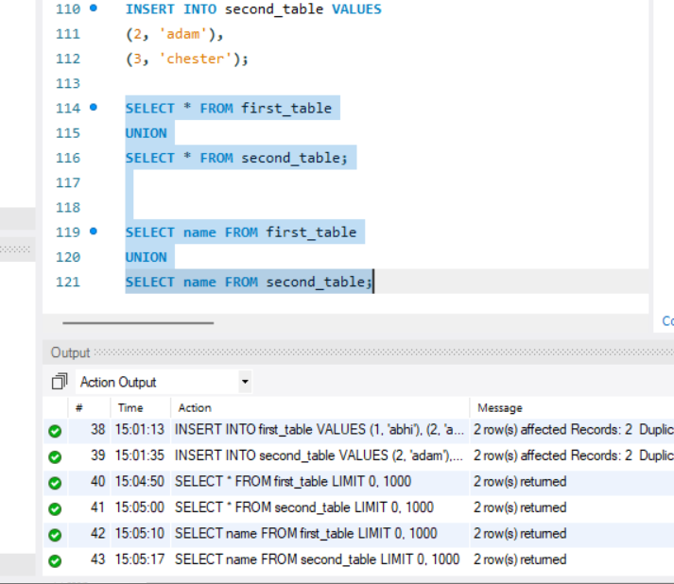
Step 13: Union All Operations
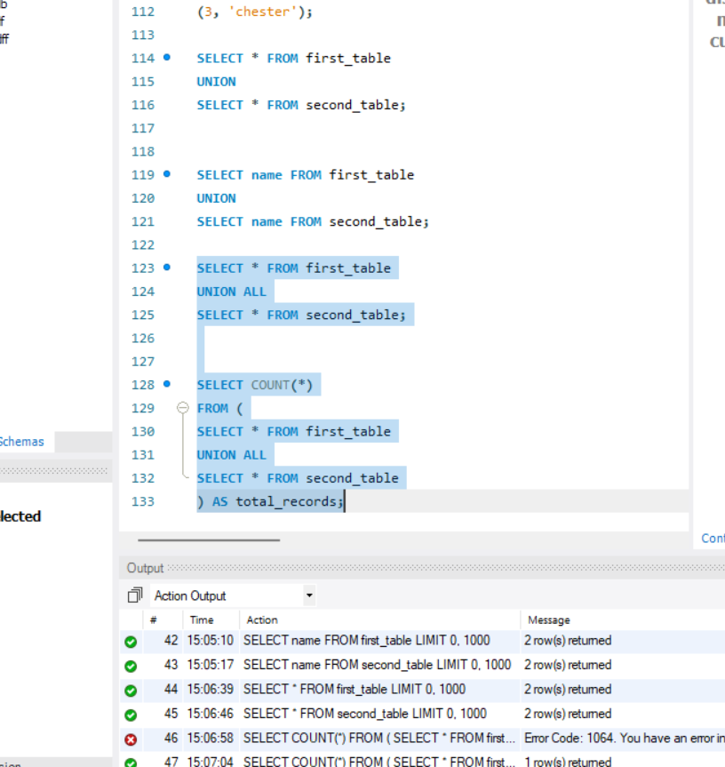
Step 14: Intersect Operations
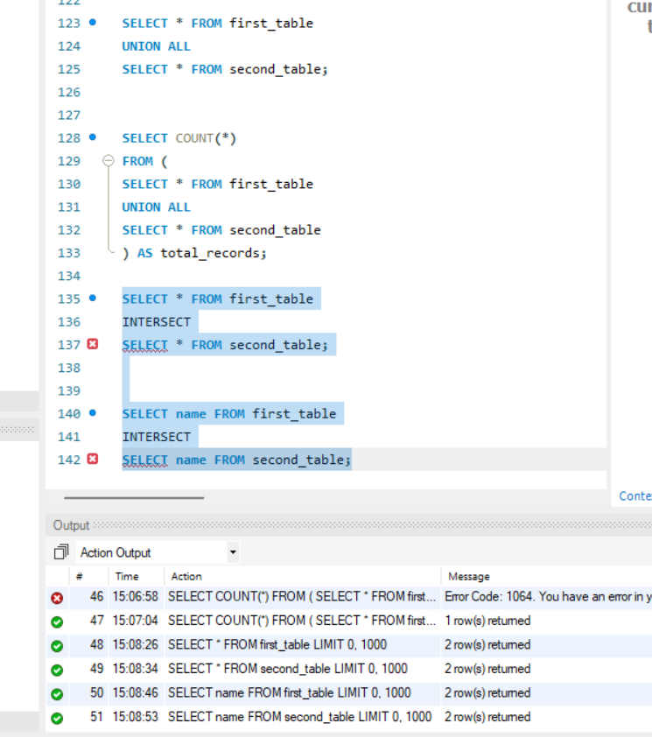
Step 15: Minus / Except Operations
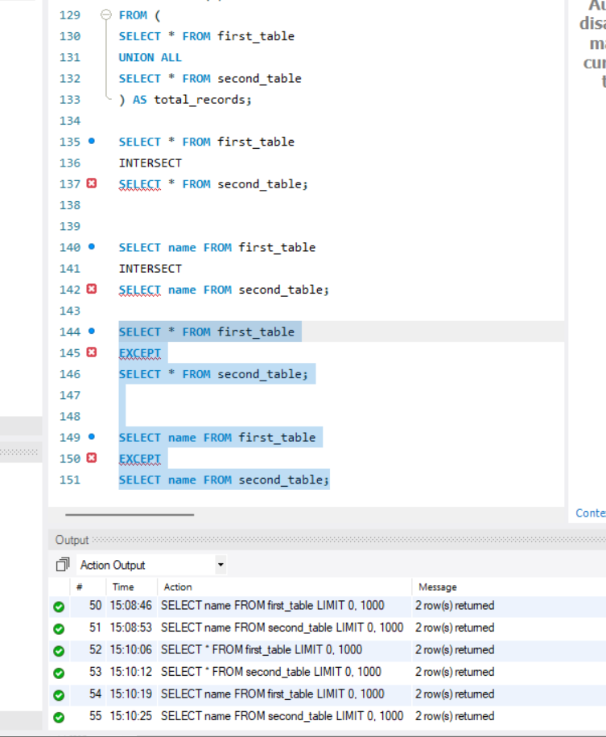
Step 16: Advanced Queries with Aliases and Case Expressions
